Exercise 3: Supervised Classification
In this exercise, you will undertake a supervised classification of a Landsat 8 Operational Land Imager (OLI) collected on 07/29/2022 over the city of Fairbanks, Alaska using ArcGIS Pro and the Image Analyst Extension. In this exercise, you will specifically compare the support vector machine and random forest machine learning algorithms.
Topics covered in this exercise include:
- Understand the bands’ information of the Landsat 8 OLI image
- Interpret multispectral imagery to create training data
- Use training data, input imagery, and machine learning algorithms to create land cover classification models
- Use trained models to predict images and create land cover predictions
- Assess and compare classification performance using classification results

Data
This project contains one raster layer: Landsat8_Fairbanks_AL.tif, representing the city of Fairbanks, and its surrounding area in Alaska, US. The bands have been stacked into a single, multiband image using the Mosaic function in ArcGIS Pro. See the table 1 for additional information. One vector point layer: validationpoints2.shp, representing the “ground truth” for validating final classification products. Download Exercise_3.zip. Save it in the location you are choosing and unzip it by right-clicking on Exercise_3.zip. In the drop-down window, choose “Extract All”.

Table 1. Landsat 8 OLI Bands included in the classification
Band | Included | Band Number in Stack | Native Spatial Resolution
Band 1 (Coastal Aerosol) | No | NA | 30 m
Band 2 (Blue) | Yes | 1 | 30 m
Band 3 (Green) | Yes | 2 | 30 m
Band 4 (Red) | Yes | 3 | 30 m
Band 5 (Near Infrared) (NIR) | Yes | 4 | 30 m
Band 6 (SWIR 1) | Yes | 5 | 30 m
Band 7 (SWIR 2) | Yes | 6 | 30 m
Band 8 (Panchromatic) | No | NA | 15 m
Band 9 (Cirrus) | No | NA | 30 m
Band 10 (Thermal Infrared) 1 | No | NA | 100 m
Band 11 (Thermal Infrared) 2 | No | NA | 100 m

Step 1. Create a Project in ArcGIS Pro

- In the search bar at the left corner, type “ArcGIS Pro”. You will see the software “ArcGIS Pro”. Click on it, the ArcGIS Pro will be loaded.
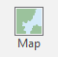
Note, this can also be done by navigating to All Apps followed by the ArcGIS Folder. Within the ArcGIS Folder, select ArcGIS Pro.
- Create a project to host your maps by clicking on the Map icon.
- The Create a New Project window should be shown. Define the name for your project. You can give any name that you prefer. Then click on Folder icon, find the location where you want to save your project.
- You do not need to change others.
- Click on OK.

Step 2. Explore Band Combinations

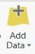
You will first add Landsat8_Fairbanks_AL.tif layer to the map within your project.
- Click the Add Data button. This button is available under the Map Tab within the Layer Section.
- Navigate to your directory that stores the data. Specifically, navigate to the Exercise_3 folder.

Within the folder, select the Landsat8_Fairbanks_AL.tif. Click OK to add it to the map.

You will now explore different band combinations.
- Right-click on Landsat8_Fairbanks_AL.tif layer in the Contents Pane, in the drop-down menu, select Symbology.
- In the Symbology window, set Primary symbology to “RGB”. Set Red to “Band_3”, Green to “Band_2”, and Blue to “Band_1”.
- You do not need to change others

This band combination is a natural combination, meaning the colors are close to the real-world colors for each ground feature. In this class, you will classify the image into three classes: developed, vegetation, and water. So, you will need to identify them in the imagery, to collect the training data. You can also change the base map to help you recognize different classes.

- Click on Basemap icon under Map Tab. In the drop-down menu, select Imagery.
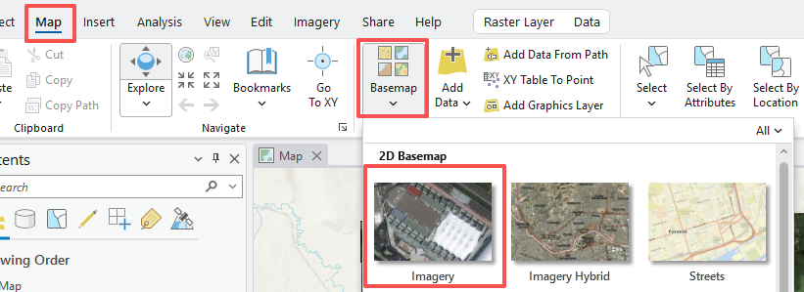

In most cases, The Imagery base map has a high resolution than the Landsat 8. If you zoom in, you can see clearer images. Note, you will need to turn off Landsat8_Fairbanks_AL.tif layer to see the Imagery base map.

You can also change the band combination to a false color combination. One of such combination is near-infrared, red, and green combination, which is good for analyzing vegetation health.

- Highlight Landsat8_Fairbanks_AL.tif layer in the Contents Pane.
- In the Symbology window, set Primary symbology to “RGB”. Set Red to “Band_4”, Green to “Band_3”, and Blue to “Band_2”.
- You do not need to change others

Deliverable 1. Screenshot your map showing the false color combination. (5 Points)
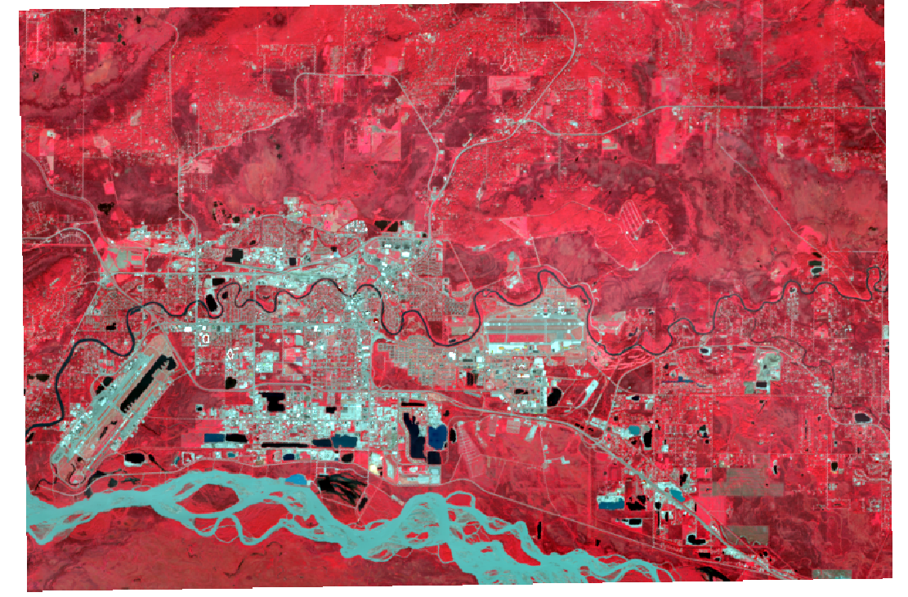

The image colors should be changed. In this combination, plants-covered land appears red. The denser plant is darker red. Cities and barren are gray or tan, and clear water is black. In some watery body, if the water was muddy, the sediment would reflect the light, which makes the water looks blue. This is likely the case shown in our image for the meandered river in the southern part of the image.

You will use the false color combination to find the different classes.

Developed
This class will include all commercial, urban, and residential areas. Common features within developed areas include buildings, roads, yards, and parking lots. In the image, it looks like the following.

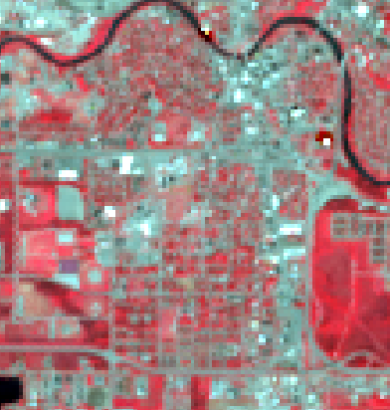

Vegetation
This class will include all vegetated areas, such as forests, croplands, and grasslands. Do not include small stands of trees in residential areas.
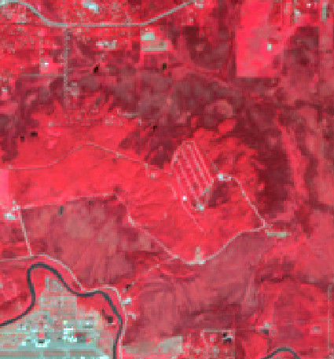

Water
This class will include all water features, such as rivers, ponds, and lakes.
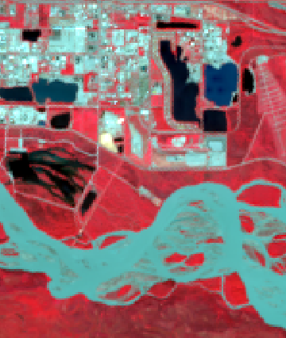

Step 3. Create Training Samples

You will now need to create the training samples for each of the three classes. You should collect a minimum of 20 samples for each class. Make sure to capture the spectral variability of each class.

- Highlight Landsat8_Fairbanks_AL.tif layer in the Contents Pane.
- Under the Imagery Tab, expand the Classification Tools at the Image Classification group area, in the drop-down menu, select Training Samples Manager.
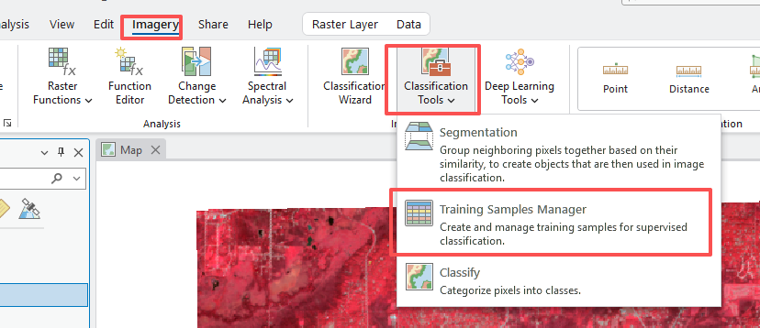
- In Training Samples Manager window, you will see there is a default NLCD2011 classification system, with several land cover types.

We can create a new class system or edit the existing one. We will use the latter in the exercise.
- Right-click on NLCD, in the drop-down menu, select Edit Properties.
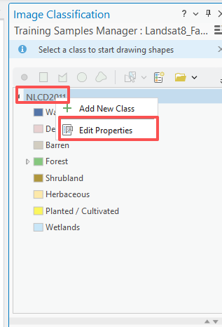
- In the Edit Properties window, set Name to “Lab3_classes” or any name you prefer. Set Organization to “UCA” and Description to “This is generated for the classification in ArcGIS Pro”.
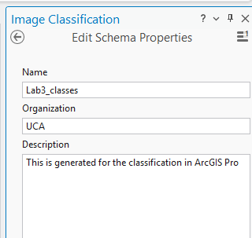
- Click on Save.
- Right-click on Barren, in the drop-down menu, select Edit Properties.
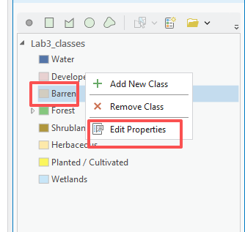
- In the Edit Properties window, change Name to “Vegetation”, change color to your favorite color.
- Keep the Value as “30”. It means that 30 represents the vegetation.
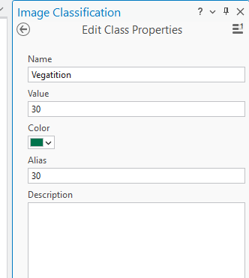
- You do not need to change others.
- Click on OK.

Question 1. What is the value for Water and Developed, respectively? (5 Points) (Hint, you need to check it under the Edit Properties window) (5 points)

10 and 20

You will now need to delete other classes.

- Right-click on Forest, in the drop-down menu, select Remove Class.
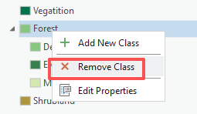

Use the same method, to remove all other classes, except for Water, Developed, and Vegetation. Your classification system should look like the below image.
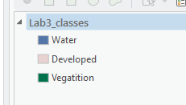

- Click on the Save icon to save your classification system. You need to indicate the Output location.
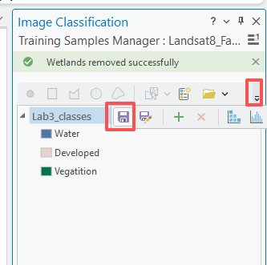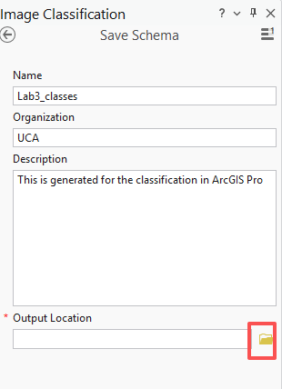

Deliverable 1: Screenshot your map showing 3 classes in your classification system. (5 points)

Now, you will start to select the samples for each class. You need to select at least 20 samples for each of them. Note, you want your samples to spread out of the maps, not concentrate on one place.

- Highlight Water, a toolbar is activated at the top of it. You can select samples using a rectangle, polygon, circle, or freehand shape. In this exercise, you will use a polygon (i.e., the third one)
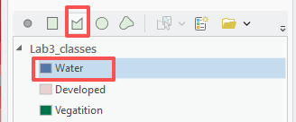

Click on the polygon, in the imagery, find the water. Draw a polygon. That will be your first sample. Note, you will refer to Step 2 to find the class.
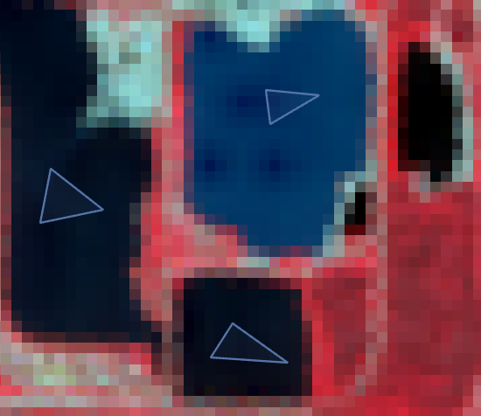

- You will need to draw at least 20 samples.
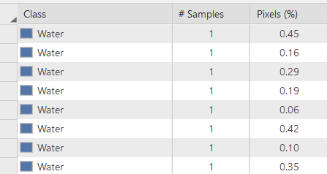
If some samples were not in a good place, you can delete them and redraw them. At the bottom part of the Training Samples Manager window, you can see the sample list that you just created.

- Highlight the samples, and click the cross icon if you want to delete some samples.

Use the same method to collect the training samples for Developed and Vegetation. After finishing, your imagery should look like the following map.
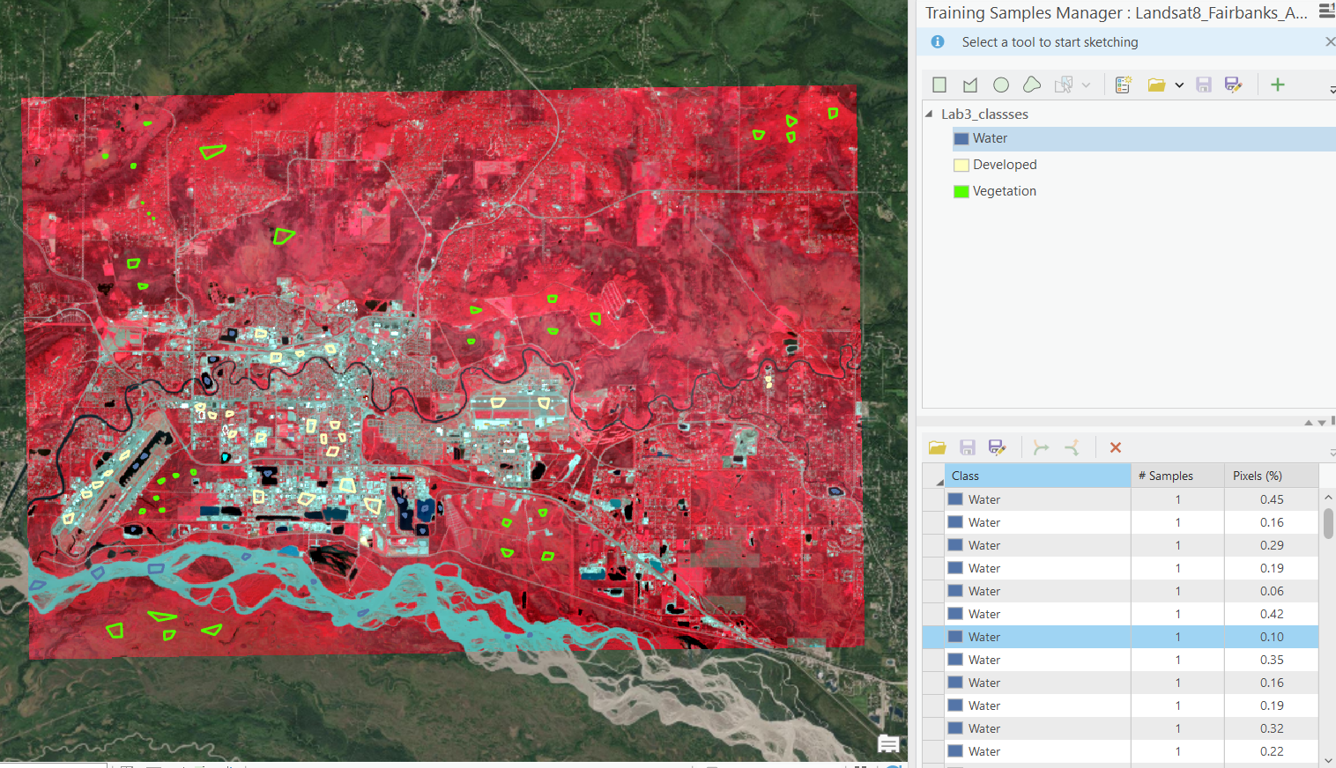

Deliverable 2. Screenshot your map showing training samples. (5 Points)

- Click on Save icon to save your training samples. Note, the Save icon is just at the top of the samples list.
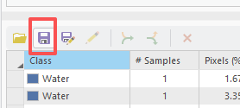
- Navigate to the locations that you want to save your training samples. Set the Name to “traningsample.shp”
- Click on OK.

Step 4. Training Classifier

You will now be ready to use the Landsat image, training samples, and Train Support Vector Machine Classifier/Train Random Tress Classifier tools to train the support vector machines and random trees classifier.

- Navigate to Analysis Tab, click on Tools.
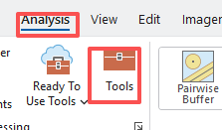
- In the Geoprocessing window, expand Image Analyst Tools, followed by Classification and Pattern Recognition.
- Click on Train Random Tress Classifier.
- In the Train Random Tress Classifier window, set Input Raster as “Landsat8_Fairbanks_AL.tif”.
- Set Input Training Sample File as “trainingsample.shp”. Note, this is the file you created in Step 3. You may need to use the browse icon to locate it.
- Set the Output Classifier Definition File to “Landsat8_RandTree.ecd”.
- You do not need to change others.
- Click on Run.

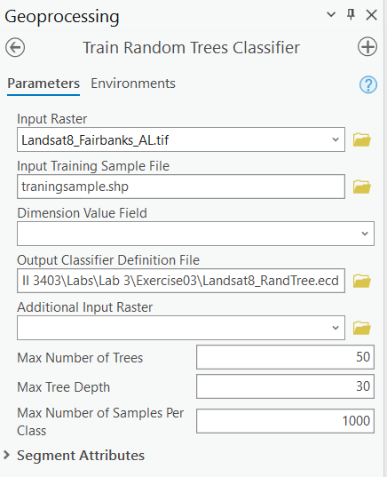

Now you will train the support vector classifier.

- In the Geoprocessing window, expand Image Analyst Tools, followed by Classification and Pattern Recognition.
- Click on Train Support Vector Machine Classifier.
- In the Train Support Vector Machine Classifier window, set Input Raster as “Landsat8_Fairbanks_AL.tif”.
- Set Input Training Sample File as “trainingsample.shp”. Note, this is the file you created in Step 3. You may need to use the browse icon to locate it.
- Set the Output Classifier Definition File to “Landsat8_SuppVector.ecd”.
- You do not need to change others.
- Click on Run.
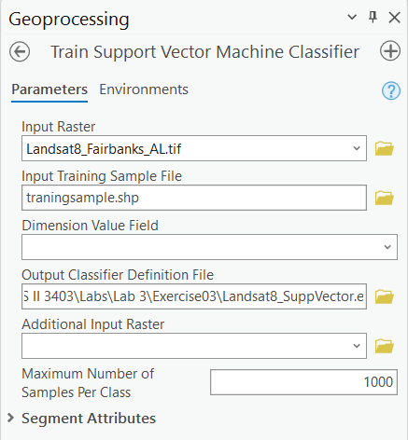

Step 5. Classify the Image

Now, you are ready to use the trained random forest model and support vector machine model, and the Classify Raster Tool to classify the image and obtain the corresponding classification maps.

- In the Geoprocessing window, expand Image Analyst Tools, followed by Classification and Pattern Recognition.
- Click on Classify Raster tool.
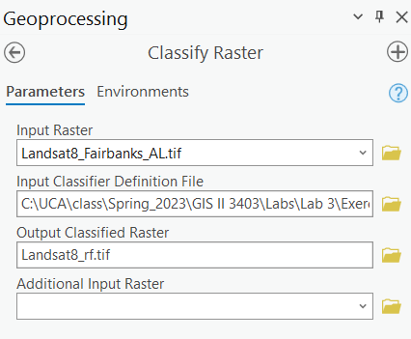
- In the Classify Raster window, set Input Raster as “Landsat8_Fairbanks_AL.tif”.
- Set Input Classifier Definition File as “Landsat8_RandTree.ecd”. Note, this is the file you created in Step 4. You may need to use the browse icon to locate it.
- Set the Output Classified Raster to “Landsat8_rf.tif”.
- You do not need to change others.
- Click on Run.

Deliverable 3. Screenshot your map showing random forest classified map. (5 Points)
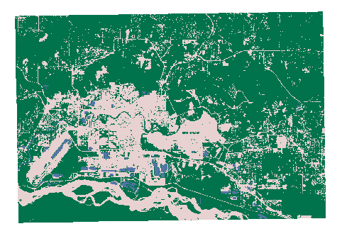
Use same method to get the support vector classified map. Note, you need to set Input Classifier Definition File as “Landsat8_SuppVector.ecd” and the Output Classified Raster to “Landsat8_svm.tif”.

Deliverable 4. Screenshot your map showing support vector machine classified map. (5 Points)

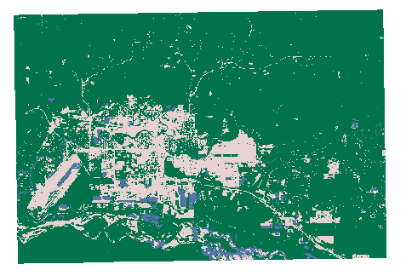

Step 6. Assess the Classification Results

You will first compare the results from random forest and support vector classification methods.

- Navigate to Analysis Tab, click on Tools.
- In the Geoprocessing window, expand Image Analyst Tools, followed by Multidimensional Analysis.
- Click on Summarize Categorical Raster.
- In the Summarize Categorical Raster window, set Input Categorical Raster as “Landsat8_rf.tif”. Set Output Summary Table as “rf_Summarize”.
- You do not need to change others.
- Click on Run.

The rf_Summarize table should be added to the Contents Pane. Use the same method to generate svm_Summarize table for Landsat8_svm.tif. These tables record the number of pixels for each class.

- Right-click on rf_Summarize table, in the drop-down menu, select Open.

Question 2. What is the number of pixels for water, developed, and vegetation, respectively? (5 Points)
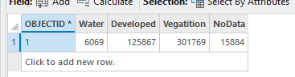

Use the same method to open the svm_Summarize table.

Question 3. What is the number of pixels for water, developed, and vegetation, respectively? Which class show most difference compared to that from random forest classification (5 Points)
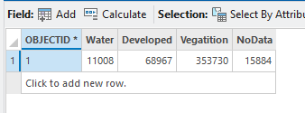
developed
Now, you will visually compare results from random forest and support vector machine classification methods with the Imagery base map.

- Close the two tables. Turn off the Landsat8_Fairbanks_AL.tif and Landsat_svm.tif in the Contents pane.
- Highlight the Landsat_rf.tif layer. Navigate to Raster Layer Tab, click on Swipe.
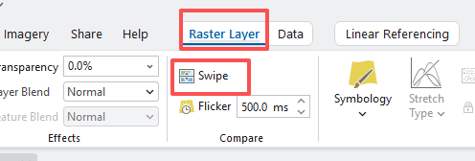
- In the image, drag your mouse to swipe your Landsat_rf image, you should be able to see the Imagery base map.
- Compare your classified map with the Imagery base map.

Use the same method to compare your classified map from the support vector machine method with the Imagery base map.

Question 4. Through visual assessment, which classification results are better? (5 Points)

Rf is better

Finally, you will use the provided validation data and the Compute Confusion Matrix Tool to quantitatively assess the classification results.

Before that, you will need to extract the classification results to the validation points.

- Load the validationpoints2.shp into the map by clicking on Add Data icon under Map tab.
- Right-click on validationpoints2.shp layer, in the drop-down menu, select Attribute Table.

You should see there is a classified Field with value of -1. This is the field that you will update it using the values from random forest and support vector machine classified maps, respectively. Note, 10 represents water, 20 represents developed, and 30 represents vegetation.

- Navigate to Analysis Tab, click on Tools.
- In the Geoprocessing window, expand Image Analyst Tools, followed by Classification and Pattern Recognition tool.
- Click on Update Accuracy Assessment Points.
- In the Update Accuracy Assessment Points window, set Input Raster or Feature Class Data as “Landsat8_rf.tif”. Set Input Accuracy Assessment Points as “validationpoints2”. Set Output Accuracy Assessment Points as “validationpoints2_update”. Set Target Field as “Classified”.
- You do not need to change others.
- Click on Run.
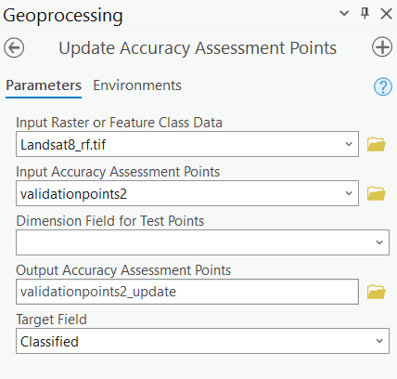
The validationpoints2_update layer should automatically add to the Contents Pane. Open the attribute table for the layer, the Classified Field should be updated.

Now, you are ready to generate the confusion matrix.

- In the Geoprocessing window, expand Image Analyst Tools, followed by Classification and Pattern Recognition tool.
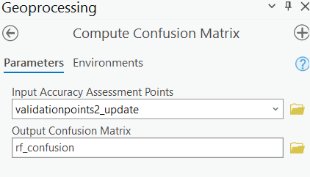
- Click on Compute Confusion Matrix.
- In the Compute Confusion Matrix window, set Input Accuracy Assessment Points as “validationpoints2_update”. Set Output Confusion Matrix as “rf_confusion”. Note, you need to save the matrix table into the geodatabase, otherwise it may not be successful.
- Click on Run.

The rf_confusion table should be automatically added to Contents Pane. Use the same method to generate the confusion matrix for your support vector machine classified map. Note, you will need to generate an updated Accuracy Assessment Points using the Landsat8_svm.tif layer. Name the confusion matrix as “svm_confusion”.

Open the rf_confusion and svm_confusion tables to answer the following questions.

Deliverable 5. Screenshot your both confusion matrices. (5 Points)

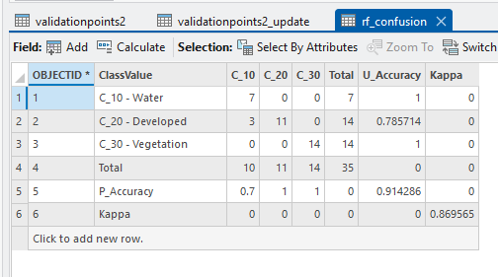
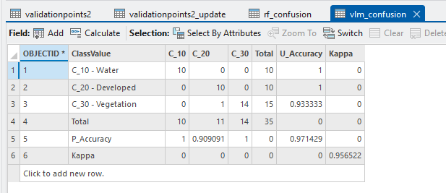

Question 5. Which classifier yield the highest overall classification performance based on Kappa value? (5 Points) (Hint, the higher Kappa value represents higher overall accuracy). Is that consistent with your visual assessment?

SVM is better

End of Exercise

Homework
Please submit a word file with 5 questions and 5 deliverables. Please submit through Blackboard.

